|  |  |  |  |
| --- | --- | --- | --- |
|  | **Course Name: Web Technology Lab** | **EXPERIMENT NO. 5** | |
| **Course Code: 23CP306P**  **Faculty: Dr. Punit Gupta** | **Branch: CSE** | **Semester: V** |

**Experiment 5:**

**Code:**

**1) Multiplication Table Page:**

<!DOCTYPE html>

<html lang="en">

<head>

  <meta charset="UTF-8">

  <meta name="viewport" content="width=device-width, initial-scale=1.0">

  <title>Multiplication Table</title>

  <link rel="stylesheet" href="style.css">

</head>

<body>

  <nav>

    <table>

      <tr>

        <td><a href="./profile.html">Home</a></td>

        <td><a href="./about.html">About</a></td>

        <td><a href="./skills.html">Skills</a></td>

        <td><a href="./project.html">Projects</a></td>

        <td><a href="./login.html">Login</a></td>

        <td><a href="./register.html">Register</a></td>

        <td><a href="./review.html">Review</a></td>

        <td><a href="./multiplication_table.html" style="color: crimson;">Multiplication</a></td>

        <td><a href="./SimpleInt.html">Simple Interest</a></td>

      </tr>

    </table>

  </nav>

  <h2>Multiplication Table</h2>

  <div class="inputs">

    <label for="num">Enter a Number :</label><br>

    <input type="number" id="num" placeholder="Enter number" class="textbox"><br><br>

    <button class="submit-btn" onclick="generateTable()">Generate Table</button>

    <button class="clear-btn" onclick="clearTable()">Clear</button>

    <div id="output" style="margin-top:20px; text-align:left;"></div>

  </div>

  <script>

    function generateTable() {

      let n = document.getElementById("num").value;

      let output = document.getElementById("output");

      output.innerHTML = "";

      if (n === "") {

        output.innerHTML = "<p style='color:red;'>Please enter a number!</p>";

        return;

      }

      if (n <= 0) {

        output.innerHTML = "<p style='color:red;'>Please enter a positive number greater than 0!</p>";

        return;

      }

      let tableHTML = "<h3>Multiplication Table of " + n + ":</h3><div class=\"table-box\">";

      for (let i = 1; i <= 10; i++) {

        tableHTML += "<div class=\"row\">" + n + " X " + i + " = " + (n * i) + "</div>";

      }

      tableHTML += "</table-box>";

      output.innerHTML = tableHTML;

    }

    function clearTable() {

      document.getElementById("num").value = "";

      document.getElementById("output").innerHTML = "";

    }

  </script>

</body>

</html>

**2) Simple Interest Page:**

<!DOCTYPE html>

<html lang="en">

<head>

  <meta charset="UTF-8">

  <meta name="viewport" content="width=device-width, initial-scale=1.0">

  <title>Multiplication Table</title>

  <link rel="stylesheet" href="style.css">

</head>

<body>

    <nav>

        <table>

        <tr>

            <td><a href="./profile.html">Home</a></td>

            <td><a href="./about.html">About</a></td>

            <td><a href="./skills.html">Skills</a></td>

            <td><a href="./project.html">Projects</a></td>

            <td><a href="./login.html">Login</a></td>

            <td><a href="./register.html">Register</a></td>

            <td><a href="./review.html">Review</a></td>

            <td><a href="./MulPage.html">Multiplication</a></td>

            <td><a href="./SimpleInt.html" style="color: crimson;">Simple Interest</a></td>

        </tr>

        </table>

    </nav>

    <div class="calc-generator">

        <div class="calc-box">

            <h2>Simple Interest Calculator</h2>

            <label for="principal">Principal Amount:</label>

            <input type="range" id="principal" min="0" max="10000000" step="1" value="10000" oninput="syncInputs('principal')">

            <input type="number" id="principalText" min="0" max="10000000" step="1" value="10000" oninput="syncInputs('principalText')" style="width: 30%;">

            <br>

            <label for="time">Time (Years):</label>

            <input type="range" id="time" min="0" max="100" step="1" value="5" oninput="syncInputs('time')">

            <input type="number" id="timeText" min="0" max="100" step="1" value="5" oninput="syncInputs('timeText')">

            <br>

            <label for="rate">Rate of Interest (%):</label>

            <input type="range" id="rate" min="0" max="100" step="1" value="10" oninput="syncInputs('rate')">

            <input type="number" id="rateText" min="0" max="100" step="1" value="10" oninput="syncInputs('rateText')">

            <br>

            <div id="output">

                <h3 id="finalAmount">Final Amount: ₹0</h3>

                <h3 id="interestAmount">Interest: ₹0</h3>

            </div>

        </div>

    </div>

    <script>

        function formatNumber(num) {

            return num.toLocaleString('en-IN');

        }

        function calculateSI() {

            let P = parseFloat(document.getElementById("principal").value);

            let T = parseInt(document.getElementById("time").value);

            let R = parseFloat(document.getElementById("rate").value);

            let SI = (P * R * T) / 100;

            let totalAmount = P + SI;

            document.getElementById("finalAmount").textContent = "Final Amount: ₹" + formatNumber(Math.round(totalAmount));

            document.getElementById("interestAmount").textContent = "Interest: ₹" + formatNumber(Math.round(SI));

        }

        function syncInputs(source) {

            if (source === 'principal') {

                document.getElementById('principalText').value = document.getElementById('principal').value;

            } else if (source === 'principalText') {

                document.getElementById('principal').value = document.getElementById('principalText').value;

            } else if (source === 'time') {

                document.getElementById('timeText').value = document.getElementById('time').value;

            } else if (source === 'timeText') {

                document.getElementById('time').value = document.getElementById('timeText').value;

            } else if (source === 'rate') {

                document.getElementById('rateText').value = document.getElementById('rate').value;

            } else if (source === 'rateText') {

                document.getElementById('rate').value = document.getElementById('rateText').value;

            }

            calculateSI();

        }

    </script>

</body>

</html>

**3) Style.css**

.calc-generator {

    width: 500px;

    margin: 0 auto;

    margin-top: 30px;

}

.calc-box {

    border: 1px solid #ccc;

    background-color: white;

    border-radius: 8px;

    width: 500px;

    padding: 20px;

    text-align: center;

}

.calc-box input {

    width: 80%;

    margin: 10px 0;

}

.calc-box label {

    margin-top: 15px;

    font-size: 18px;

    font-weight: bold;

}

.calc-box #output {

    margin-top: 20px;

    background-color: #f0f0f0;

    padding: 15px;

    border-radius: 5px;

}

.table-box{

    background: #f1f1f1;

    padding: 10px;

    border-radius: 6px;

    border: 1px solid #ccc;

}

.row{

    padding: 5px;

    border-bottom: 1px solid #ddd;

}

**Output:**

**Screenshot**

1) Multiplication page

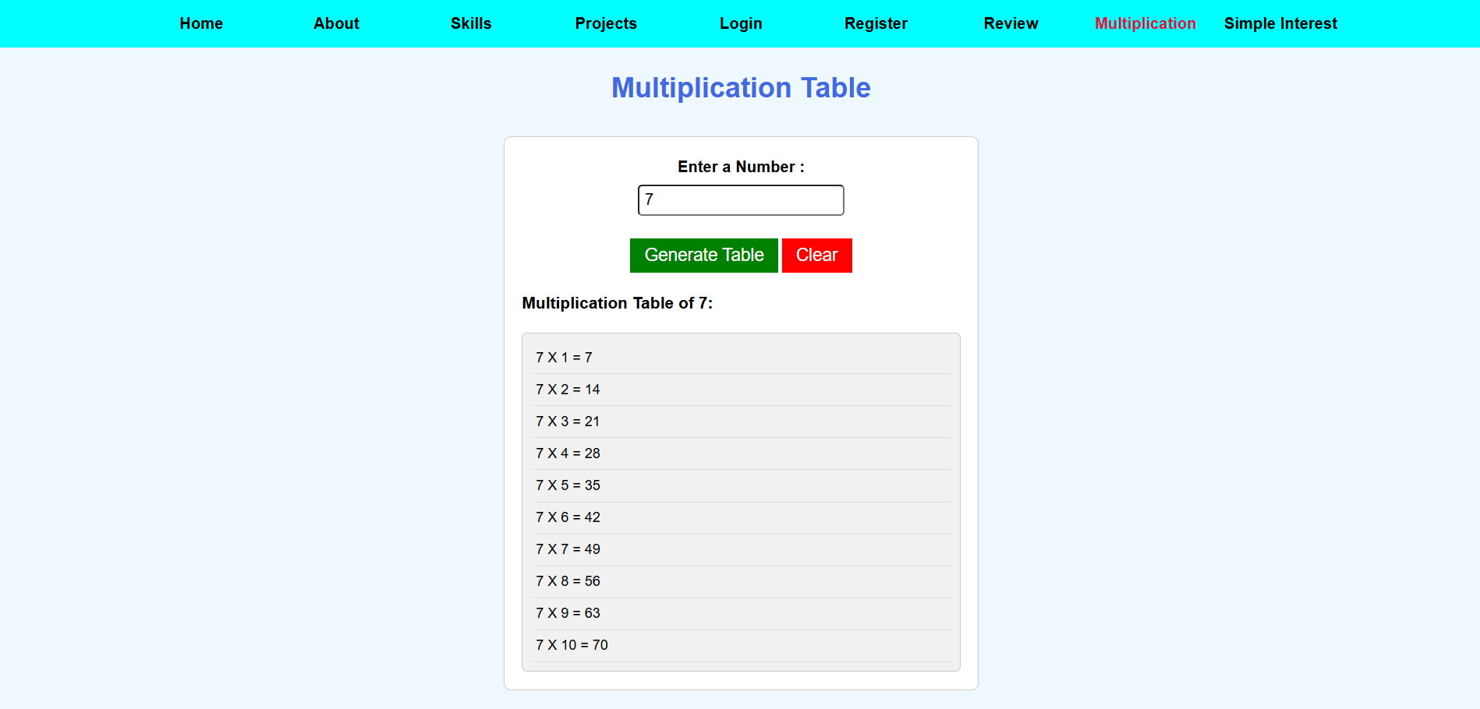

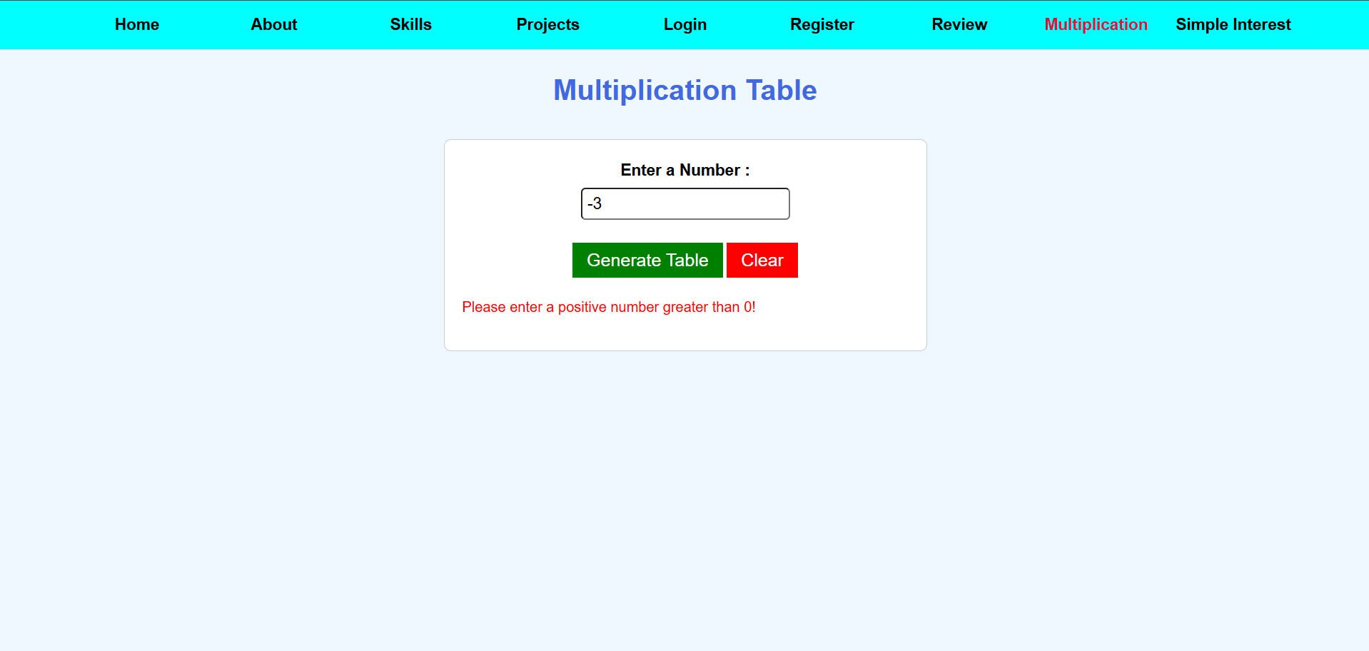

2) Simple Interest Page

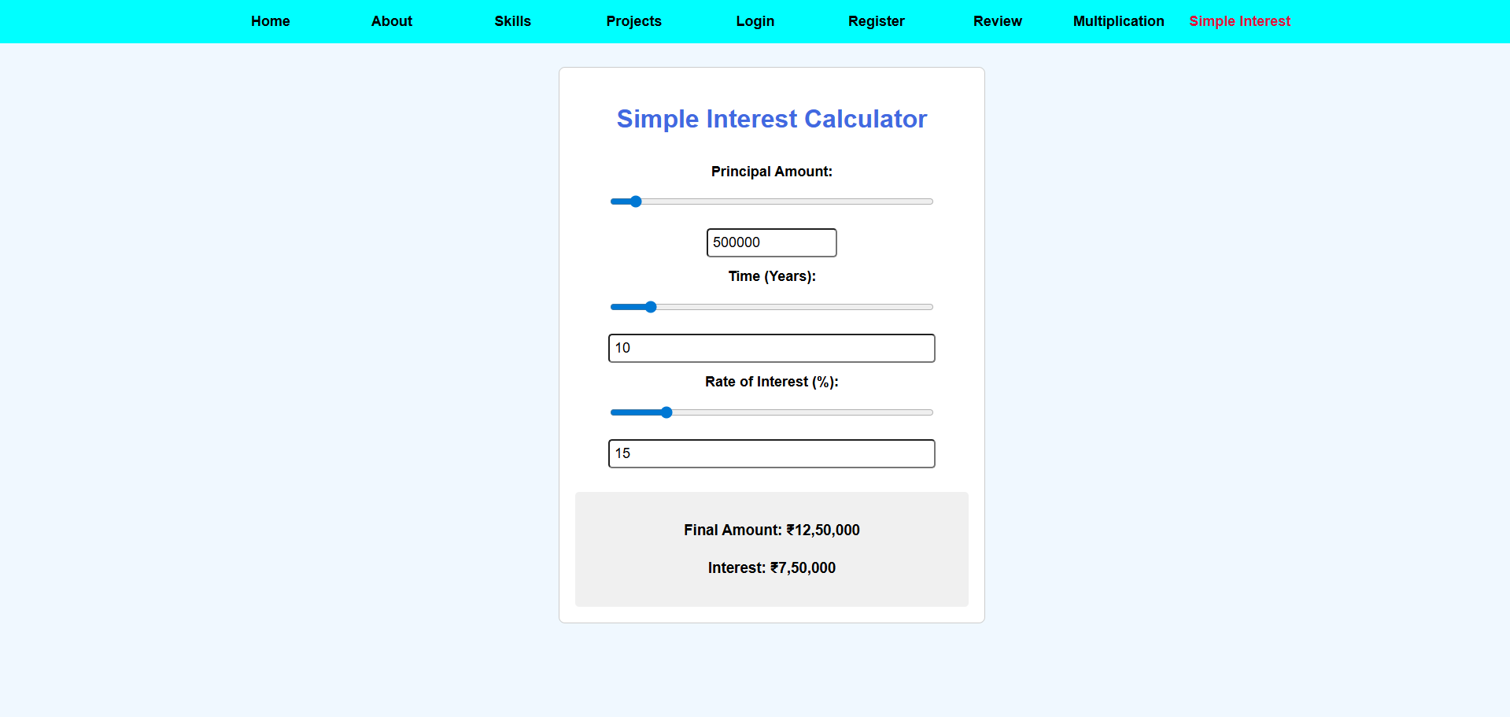

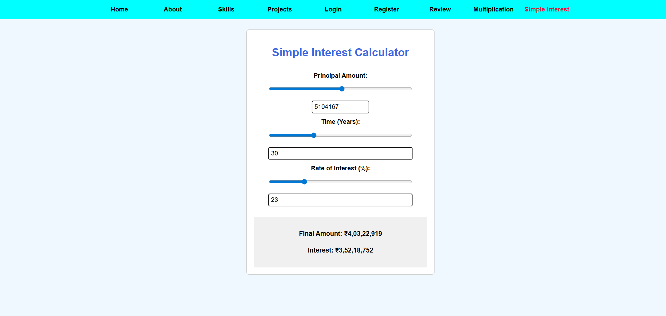

**GitHub Repository Link:**